ASSIGNMENT-2

1. Scaleset with windows OS:

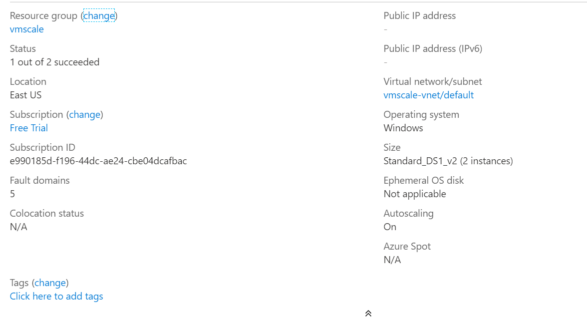

1. Scale-out and Scale-in rule with 70% & 40% threshold :

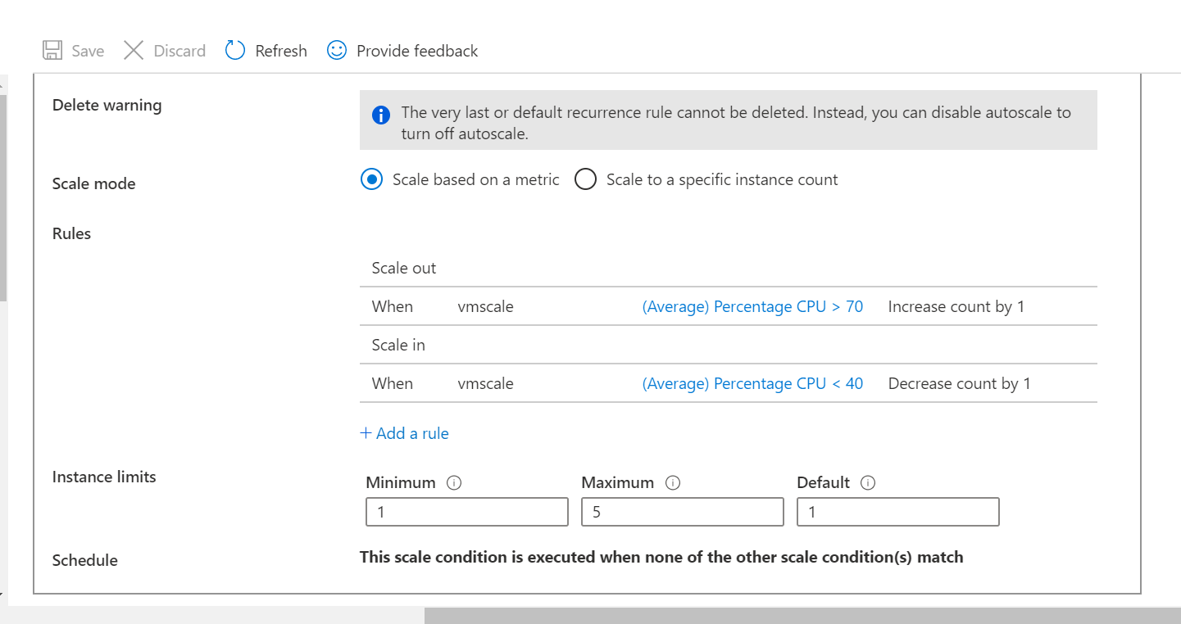

1. Storage Account of Containers with Anonymous access, and a static website :

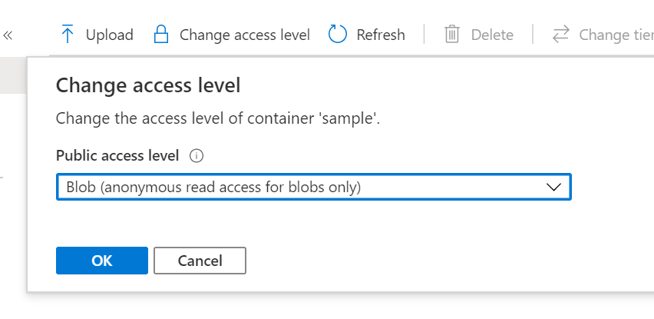

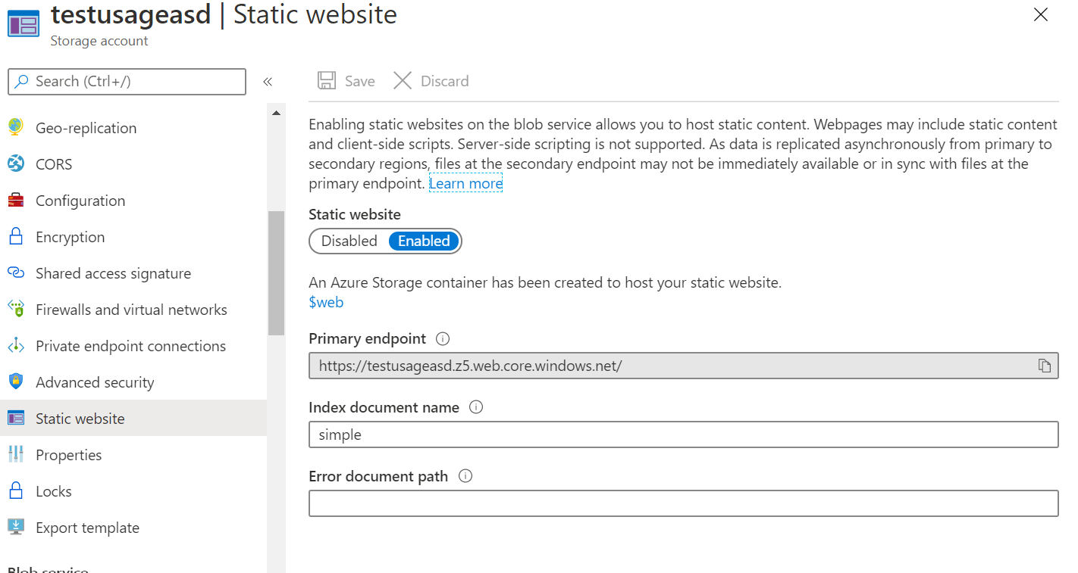

1. Two virtual machines with no public ip addresses and attached to load balancer blocking port number 3389 :

